Motorized report

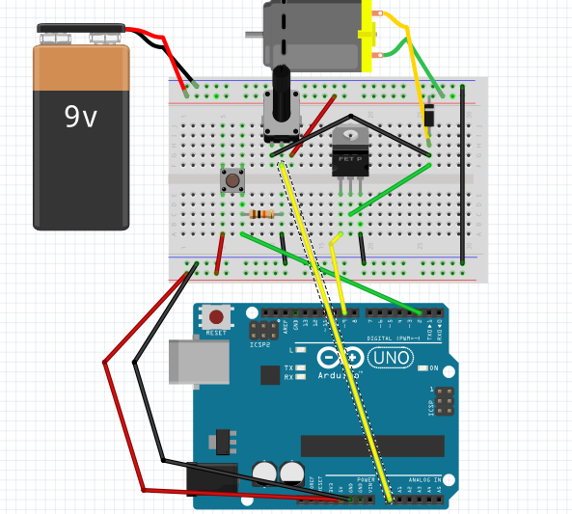

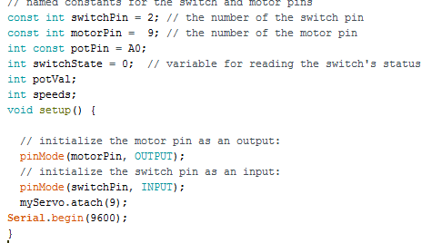

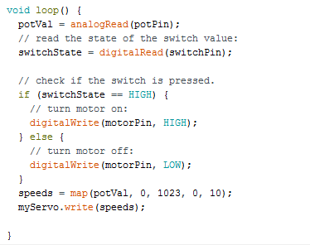

I set potentiometer for positive electrode and negative electrode of battery for through to control voltage of battery to change speed of dc motor. I use map function to set speed 0 – 10.